PUNJAB LOCAL GAME (STAPOO)

**AFSHEEN LIAQAT**

**SAJJAL BIBI**



DEPARTMENT OF COMPUTER SCIENCES

COMSATS UNIVERSITY ISLAMABAD,

ATTOCK CAMPUS –PAKISTAN

Session 2019-2021

PUNJAB LOCAL GAME (STAPOO)

*Undertaken By:*

**AFSHEEN LIAQAT**

CIIT/FA19-MCS-021/ATK

**SAJJAL BIBI**

CIIT/FA19-MCS-009/ATK

*Supervised By:*

**MISS ANUM ZAHRA**

A DISSERTATION SUBMITTED AS A PARTIAL FULFILLMENT OF THE REQUIREMENTS FOR THE DEGREE OF BACHELOR OF SCIENCE IN SOFTWARE ENGINEERING

DEPARTMENT OF COMPUTER SCIENCES

COMSATS UNIVERSITY ISLAMABAD,

ATTOCK CAMPUS –PAKISTAN

Session 2019-2021

UNDERTAKEN

We certify that this is our own work. The work has not, in whole or in part, been presented elsewhere for assessment. Where material has been used from other sources it has been properly acknowledged. If this statement is untrue, we acknowledge that we will have committed an assessment offence and shall be liable to punishable action under the plagiarism rules of HEC.

________________ ____________________

AFSHEEN LIAQAT SAJJAL BIBI

FA19-MCS-021 FA19-MCS-009

Dated: _________ Dated: _________

**Final Approval**

Certified that we have read this project report submitted by (**MS Afsheen liaqat & Ms Sajjal Bibi**) and it is, in our judgment, of sufficient standard to warrant its acceptance by Department of Computer Science, COMSATS University Islamabad, Attock Campus, for the MCS degree.

***Committee:***

1. External Examiner ____________________________

(Examiner Name)

Designation

University Name

1. Supervisor ____________________________

(Supervisor Name)

Designation

1. Head of the Department ____________________________

(HOD Name)

**Dedication**

This thesis is dedicated to: The sake of Allah, my Creator and my Master, my great teacher and messenger, Muhammad (May Allah bless and grant him), who taught us the purpose of life The COMSATS University; my second magnificent home; My great parents, who never stop giving of themselves in countless ways, To all my Teachers & Family. My friends who encourage and support me, all the people in my life who touch my heart, I dedicate this research.

**PROJECT BRIEF**

PROJECT NAME PUNJAB local games

ORGANIZATION NAME Punjab games

OBJECTIVE To promote games

UNDERTAKEN BY Afsheen Liaqat (FA19-MCS-021)

Sajjal bibi (FA19-MCS-009)

SUPERVISED BY Miss Anum Zahra

Assistant Professor

Computer Science

CUI Attock

Started On

Completed On

COMPUTER USED

SOURCE LANGUAGE

OPERATING SYSTEM Windows 10

TOOLS USED

**ACKNOWLEDGEMENT**

Allah the most Magnificent and Merciful, We are thankful to almighty for awarding us opportunity to study at a prestigious institute and honoring us with the unlimited and kind support of Knowledgeable and co-operative teachers, seniors, friends and fellows. Financial and moral support of family was also very compulsory and they played their role well. Special thanks to our supervisor **Miss Anum Zahra** who also encourage us to work hard. After all our work is the result of all the efforts of the different parts of our society that dreamed of us as a good Human Beings.

Abstract

Many international games like hockey, basketball and football are playing online platform. We want to revive Punjab traditional games because they lost their importance**.**  Punjab’s childhood and traditional games lost in the busy city life. Children of today are very busy in their mobile and computer activities. It’s hard for modern children to find the time for old day sports. Around six seven decades ago Punjab is full of joy and colors, Children played many games at their home and in the peaceful ambiance of the countryside, other indigenous games were also played with enthusiasm. There will probably be many more games like these, but there is no one left to tell about them. The names of their creators are unknown, no one to explain the rules and regulations of these simple sports. In the villages, these games were first played by older children and young children learned the rules of these games from them. There would be some such talk during these games which had to be memorized and repeated. The children memorized the words related to the game along with the game. Most of the games were attributed to one or the other. The process continued from generation to generation

Table of Contents

CHAPTER 1 18

INTRODUCTION 18

1.1 Introduction 8

1.2 Problem Statement 9

1.3 Proposed solution 10

1.4 The Scope & Objectives 10

1.5 Description Layout 10

1.6 Limitations 11

1.7 Performance Criteria 11

1.8 Software Dependencies Requirements 11

1.9 Hardware Dependencies 11

CHAPTER 2 3

BACKGROUND 3

2.1 Background 15

2.1.1Existing System 15

2.1.1.2 Gilli Danda App 15

2.1.1.2 Gully Cricket App 16

2.1.1.3 Kanchy App 18

2.1.2 Presented solution 19

CHAPTER 3 19

SYSTEM REQUIRMENTS SPECIFICATIONS 19

3.1 Requirements Specifications 20

3.2 Non-Functional Requirements 20

3.2.1 Compatibility 20

3.2.2 Reliability 20

3.2.3 Maintainability 20

3.2.4 Availability 20

3.2.5 User friendly 21

3.2.6 Scalability 21

*3.2.7 Robustness* 21

3.3 Functional Requirement 21

3.3.1 *Player*’s Requirement 21

3.3.1.1 Game Play 21

3.3.1.2 Game Menu 22

3.3.1.3 Select Game 22

3.3.1.4 Play with agent (offline mode) 22

3.3.1.5 Play with friends (online mode) 22

3.3.1.6 Select level 23

3.3.1.7 Select player 23

Table 3.7 Select player 23

3.3.1.8 Show score 24

3.3.1.9 Exit 24

4 Project Design 26

4.1 Use Case Diagrams 26

4.2 Activity Diagrams 27

4.3 Class diagram 28

4.4 Data flow Diagram (DFD) 30

Tables of figure

Figure 1 Gulli Danda 16

Figure 2 Gully Circket 18

Figure 3 Kanche 19

Figure 4 Player Use Case Diagram 27

Figure 5Activity Diagram 28

Figure 6 Class Diagram 29

Figure 7Data flow diagram 30

# CHAPTER 1

# INTRODUCTION



# 1.1 Introduction

People of Punjab entertain themselves by playing games such as “gill –Danda”, cockle chapaki, pittu gram, stapoo, kanche and kikli etc. Many of these games were popular earlier among children in Punjab’s rural and urban streets but have vanished over the last few years. Some Punjab local games are as follows,

**Kikli** is a game which is playing by girls. Two girls clasp their hands and move in circle. This was a game which was played by two or four girls and singing such words

**Kokla chapaki** is another popular game which is played in different villages of Punjab. Both boys and girls play it. Children sitting in a circle not to look back. The cloth is then dropped at the back of children. If it is discovered before the child who had placed it there had completed the round, the child who discovered the cloth would run after him with it till he sits in the place vacated by the one who had discovered the cloth.

**Gilli-danda** is basically a game for the boys and simplest version of modern played in the rural areas and small towns. To play these games, one needs a long stick named as “Danda” and a short stick with tapered ends generally known as Gilli. The danda is used to flick the short Gilli into the air, and hit again to make it travel to a maximum distance.

**stapoo** which also known as Chinju is a popular rural game. This game is played with stone. The player need a flat stone and a flat ground on which the grid can draw. Square are drawn within grid and are numbered in sequence in which they are to be hopped. First threw a stone on a first number. Leaving that particular box jump on all the rest boxes and turn on the last box and reverse.

**Kanche** is another popular game for boys which played in a small town. The rules of this games are as one has to strike out of the way the marble thrown by the other boy or with a gentle blow from one marble, push the other marble, so that it drifts into the hole. Then opponent gets his turn to strike the other person’s Goli. The person, who gets all the Goli from the hole, is a winner of the game.

Our android application will provide an online platform for playing to these game. We are making the application for being revived traditional games for two reasons

* First, these games are going extinct there is a need to preserve these as they are an important part of Punjab’s traditional culture
* Secondly, these games are non-competitive and entertaining and help children to develop skill. We want to promote our traditional games which are playing in Punjab.

## Problem Statement

Children of today are very busy in their mobile and computer activities. It’s hard for modern children to find the time for old day sports. Around six seven decades ago Punjab is full of joy and colors, Children played many games at their home and in the peaceful ambiance of the countryside, other indigenous games were also played with enthusiasm. There will probably be many more games like these, but there is no one left to tell about them. The names of their creators are unknown, no one to explain the rules and regulations of these simple sports. In the villages, these games were first played by older children and young children learned the rules of these games from them. There would be some such talk during these games which had to be memorized and repeated. The children memorized the words related to the game along with the game. Most of the games were attributed to one or the other. The process continued from generation to generation

## Proposed solution

To resolve the problems related to stapoo in Pakistan, we have tried to contribute our part in this. We are bringing a proper platform to help the girls and also to promote the sport of stapoo in Pakistan. The users of this app will be able to find the game through our application

## The Scope & Objectives

Our project has following objectives that are given below.

* Different games are available on same platform.
* User can play game on both online and offline mode.
* In offline mode user can play game with computer agent.
* In online mode multiuser can play game with each other.
* At the end of game player see their grades and it will give the reward to players.
  1. **Description Layout**

This documentation content explains the steps that are required to complete project.

The report documents the overall process including

* + Background
  + Requirements specifications
  + Project design
  + Implementation
  + Testing

This documentation report also contains relevant figures and tables.

## Limitations

* Internet availability is required 3G/4G
* It is beneficial for girls.
* Information provided would be accurate and update time to time about game.

## Performance Criteria

* This Android application responds quickly.
* This Android application is easy to understand for users.
* This Android application will be user friendly, and the user can get avail opportunity by using this application.

## Software Dependencies Requirements

* Unity 3D
* Programming language C#
* Adobe photo-shop for designing
* MS word for documentation
* MS power point for presentation
* UML Star for designing diagram.

## Hardware Dependencies

* RAM:4GB
* Smart Mobile Phone: Android

# CHAPTER 2

# BACKGROUND

# 2.1 Background

In this section**,** we study some background knowledge of existing applications. We found many applications on Google play store. Our application will provide an online platform for playing game.

## 2.1.1Existing System

### 2.1.1.2 Gilli Danda App

Flick your finger and make a Hit! Experience a "real-life like" Gilli Danda!Flick your finger and make a Hit! Experience a “real-life like” Gilli Danda simulation!!Gilli Danda -Tip Cat is an ancient game with Origin over 2500 years ago.Gilli Danda is believed to be the origin of Western games such as Cricket, Baseball and Softball.This game is played with two sticks, a larger one called Danda (Dandan), which is used to hit the smaller one, the Gilli (Gulli).

**One Flick Easy Control:**

You only use flick to control the Gilli in the game. The more accurate you flick your finger to hit the Gilli, it is more likely that you will hit the Gilli Further.

**The rule is simple:**

Flick your finger with the same feeling in which you would swing Danda in real life. Think of your finger as a Danda, and flick it with speed and accuracy.

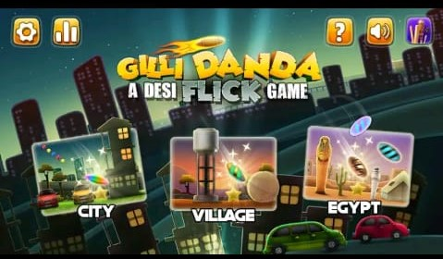

Figure 1 Gulli Danda

### 2.1.1.2 Gully Cricket App

Choose your own team combination and manage the batting order to blast your rival teams! Select your bats, balls and stumps carefully to make sure you win all 100 + matches!

3 Massive Game Modes: Arcade Mode, Tournament Mode and Gully Ka Raja:

**1. Arcade Mode:**

a) 5 Wickets - 30 Balls: Play your best in 30 balls and get to the top of the leaderboard by scoring your best.

b) One Wicket - Unlimited Balls: Can you stay unbeaten and score your best? Test your cricket playing skills in this challenging mode.

**2. Tournament Mode:**

15 different Tournaments to be won: Play against various teams in and around your gully. Earn coins by winning matches. Upgrade your bat, ball and stumps to play with the best combination and win against tough opponent teams.

**3. Gully Ka Raja:**

Beat 15 different teams and conquer 3 different Gullys. These teams will come back and keep challenging you even after you have conquered the gully. So, you have to always keep winning to be the Raja of these Gullys. Let’s see who can remain the undisputed King here!

**GULLY CRICKET FEATURES:**

* Simple game play
* More than 130 Matches to be won in Tournaments and Gully ka Raja modes
* Lots of real funny moments to look out for
* Swipe to hit straight down the ground, or play the ball on the off side or leg side
* Time your shots; play with or against the spin
* Dominate your opponents using your best team combinations and WIN every match!
* Complete the daily challenges to earn more coins
* A dynamic bowling system ensures that no two matches are alike!
* Knock the ball out of the gully by upgrading your bat and ball



Figure 2 Gully Circket

### 2.1.1.3 Kanchy App

Now play Kanche (Marbles), one of the most loved childhood games on your android device with awesome graphics and sound effects.In addition to the regular gameplay, we have introduced more than 200 challenges that will immerse you into the magical world of Kanche.You can play with CPU but the real fun lies in playing with your friends online. With top of the line tech, this game can be played smoothly even on slow internet connections. You can also play with random players all over the world to give a check to your Kanche skills.This game is also called Lakhoti in Gujarati. Gotya, goti, kancha, vattu, golli gundu, bante, goli etc in other languages.



Figure 3 Kanche

### 2.1.2 Presented solution

This project will provide an easy and user friendly remedy to the users

**Comparison between Presented solution and Other Applications:**

Competitive analysis is tabulated below.

Table 2.1 Comparison Table

|  |  |  |  |  |
| --- | --- | --- | --- | --- |
| **Functionality** | **Gulli Danda** | **Gully Circket** | **Kanche** | **Stapoo** |
| History File | No | No | No | Yes |
| Multi levels | Yes | No | No | Yes |
| Online Mode | No | Yes | No | Yes |
| Offline Mode | Yes | No | No | Yes |
| Multiplayer | No | Yes | No | Yes |
| Rewards | No | No | No | Yes |
| User Friendly interface | Yes | Yes | No | Yes |
| Works for girls | No | No | No | Yes |

.

# CHAPTER 3

# SYSTEM REQUIRMENTS SPECIFICATIONS

# 

# 3.1 Requirements Specifications

System Requirements Specification (SRS) is a formal statement of the application functional and operational requirements. It serves as a contract between the developer and the customer for whom the system is being developed. The developers agree to provide the capabilities specified. The software requirements specification enlists enough and necessary requirements that are required for the project development

## 3.2 Non-Functional Requirements

In system engineering and requirement engineering, a non-functional requirement (NFR) is that requirement specifies criteria that can be used to judge the operation of a system, rather than specific behaviors. They are contrasted with functional requirements that define specific behavior or functions.

### 3.2.1 Compatibility

This application is only applicable on android phones not on any windows phones. Application is compatible with every android operating system.

### 3.2.2 Reliability

System should be reliable to provide accurate location and suggest you the expertly. The information provided is authentic and published by responsible organization.

### 3.2.3 Maintainability

The system is easy to maintain. The records of players are maintained in database.

### 3.2.4 Availability

This application would be available for farmers for 24/7 hours and farmers will be able to use it for services if they are available.

### 3.2.5 User friendly

Application GUI (graphical user interface) must be easy to use for user and make sure users don’t face any difficulty while performing any task.

### 3.2.6 Scalability

Application must have the ability to perform any task equally well, even when the traffic and maximum users use the system.

### *3.2.7 Robustness*

Our application deals with any unexpected input instead of crashing and it will show proper error message.

## 3.3 Functional Requirement

Functional requirements may be calculations, technical details, data manipulation and processing and other specific functionality that define what a system is supposed to accomplish. In other words, a functional requirement will describe a particular behavior of function of the system when certain conditions are met.

Following are some functional requirements of our project:

### 3.3.1 *Player*’s Requirement

There are some *player* requirements which are mentioned below:

### 3.3.1.1 Game Play

Table 3.1 Game Play

|  |  |
| --- | --- |
| **Name** | **Game Play** |
| Summary | In play game, player can start game from start button |
| Rationale | For playing stapoo. |
| Prerequisite | Player must have the app installed. |

### 3.3.1.2 Game Menu

Table 3.2Game Menu

|  |  |
| --- | --- |
| **Name** | **Game Menu** |
| Summary | In game menu player can select games from menu. |
| Rationale | For playing stapoo. |
| Pre-requisite | Player must have the app installed. |

### 

### 3.3.1.3 Select Game

Table 3.3 Select Game

|  |  |
| --- | --- |
| **Name** | **Select Game** |
| Summary | From Main menu player can select game and start plying. |
| Rationale | For playing stapoo. |
| Pre-requisite | Player must have the app installed. |

### 

### 3.3.1.4 Play with agent (offline mode)

Table 3.4 play with agent

|  |  |
| --- | --- |
| **Name** | **Play with agent (offline mode)** |
| Summary | Player can play game offline mode with agent because no friend will be online. |
| Rationale | For playing stapoo. |
| Pre-requisite | Player must have the app installed.  Other player must offline. |

### 3.3.1.5 Play with friends (online mode)

Table 3.5 play with friend

|  |  |
| --- | --- |
| **Name** | **Play with friends (online mode)** |
| Summary | Player can play game online mode with friends or other person through selecting persons from Facebook. |
| Rationale | For playing stapoo. |
| Pre-requisite | Player must have the app installed.  Friend must be online. |

### 3.3.1.6 Select level

Table 3.6 Select level

|  |  |
| --- | --- |
| **Name** | **Select level** |
| Summary | Player can select level of games with friends. Level will be start from easy, normal and difficult and level will be in numerical. |
| Rationale | For playing stapoo. |
| Pre-requisite | Player must have the app installed. |

### 3.3.1.7 Select player

### Table 3.7 Select player

|  |  |
| --- | --- |
| **Name** | **Select player** |
| Summary | Player can select multi player for playing. Other player will also be online for playing together. |
| Rationale | For playing stapoo. |
| Pre-requisite | Player must have the app installed. |

### 3.3.1.8 Show score

Table 3.8 Show score

|  |  |
| --- | --- |
| **Name** | **Show score** |
| Summary | Player can play see score at the end of the game. |
| Rationale | To show Score. |
| Pre-requisite | Player must have the app installed. |

### 3.3.1.9 Exit

Table 3.9 Exit

|  |  |
| --- | --- |
| **Name** | **Exit** |
| Summary | Player can exit game at the end of the game. |
| Rationale | For playing stapoo. |
| Pre-requisite | Player must have the app installed. |

Chapter 4

Project Design

# 4 Project Design

Project design is a phase in which the structure of system and the major deliverable are planned out. For any system to work properly the design of that system must be correct and flawless. Project design helps to avoid the major risks that are involved in the project development process.

## 4.1 Use Case Diagrams

A methodology that is used in the system analysis to identify, clarify, and organize the system requirements, is known as Use Case. The term system refers to a software system that is being developed or operated. A use case diagram illustrates the activities that are performed by the users of the system.

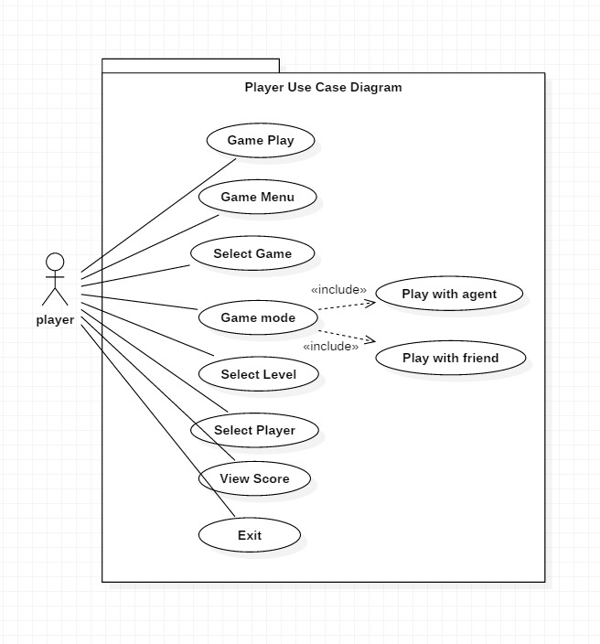 Figure 4 Player Use Case Diagram

## 

## 4.2 Activity Diagrams

An activity diagram is a very important diagram in UML. It describes the dynamic aspects of the system. Activity diagram describes the behavior of system at different situations. The activities can be described as the operations of the system.

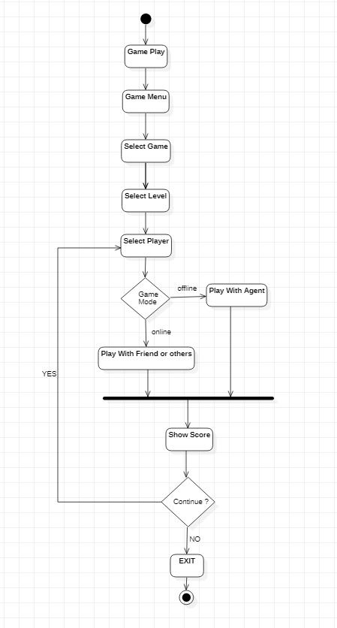

Figure 5 Activity Diagram

## 4.3 Class diagram

A class diagram represents a relation between different classes. Figure is the class diagram of our system. It shows the set of tasks that are performed by System in sequence.

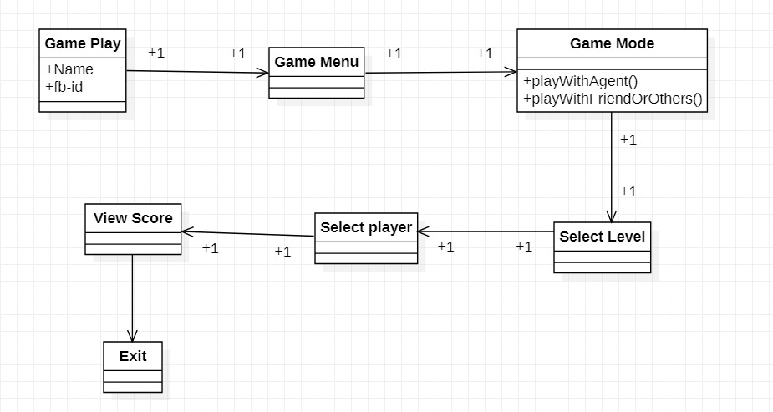

Figure 6 Class Diagram

## 4.4 Data flow Diagram (DFD)

Data flow diagrams are used to graphically represent the flow of data in a business information system. **DFD** describes the processes that are involved in a system to transfer data from the input to the file storage and reports generation.

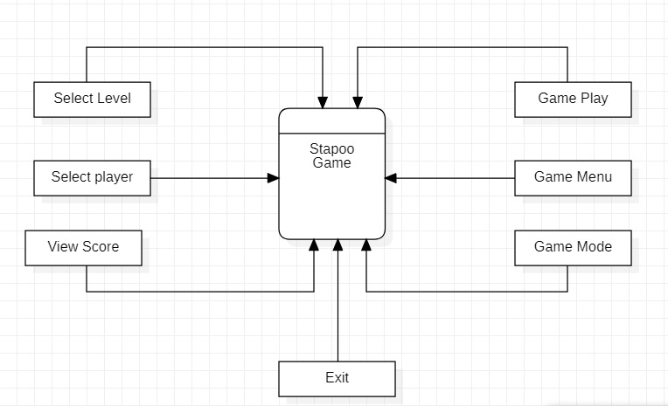

Figure 7 Data flow diagram